Okereke Chidinma Blessing
18/MHS04/004
NTD 210- Food Preservation and Processing
Assignment Submitted to Dr. Olagunju Omotola
Department of Human Nutrition and Dietetics
College of Medicine and Health Sciences
Group 1

DISCUSS THE FOLLOWING CEREAL PROCESSING METHODS, STATING THE APPLICATIONS, TYPES, EQUIPMENT USED, MERITS AND DEMERITS

BAKING OF CEREALS
CEREAL PROCESSING
Baking; is a process of cooking by dry heat, especially in some kind of oven. It is probably the oldest cooking method. Bakery products, which include bread, rolls, cookies, pies, pastries, and muffins, are usually prepared from flour or meal derived from some form of grain. Ingredients used in baking are; Flour, water, and leavening agents are the ingredients primarily responsible for the characteristic appearance, texture, and flavour of most baked products. Eggs, milk, salt, shortening, and sugar are effective in modifying these qualities, and various minor ingredients may also be used. Wheat flour is unique among cereal flours in that, when mixed with water in the correct proportions, its protein component forms an elastic network capable of holding gas and developing a firm spongy structure when baked. The proteineous substances contributing these properties are known collectively as gluten. The suitability of flour for a given purpose is determined by the type and amount of its gluten content. Those characteristics are controlled by the genetic constitution and growing conditions of the wheat from which the flour was milled, as well as the milling treatment applied.
EQUIPMENT
Baking needs an enclosed space for heating – typically in an oven. The fuel can be supplied by wood, coal, gas, or electricity. Adding and removing items from an oven may be done by hand with an oven mitt or by a peel, a long handled tool specifically used for that purpose. Many commercial ovens are equipped with two heating elements: one for baking, using convection and thermal conduction to heat the food, and one for broiling or grilling, heating mainly by radiation.
Eleven events occur concurrently during baking, some of which (such as starch gelatinization) would not occur at room temperature.
- Fats melt;
- Gases form and expand
- Microorganisms die
- Sugar dissolves
- Egg, milk, and gluten proteins coagulate
- Starches gelatinize or solidify
- Liquids evaporate
- Caramelization and Maillard browning occur on crust
- Enzymes are denatured
- Changes occur to nutrients
- Pectin breaks down.
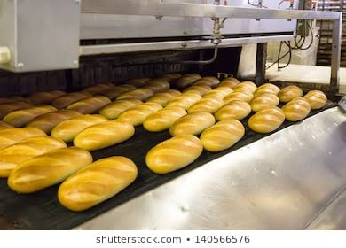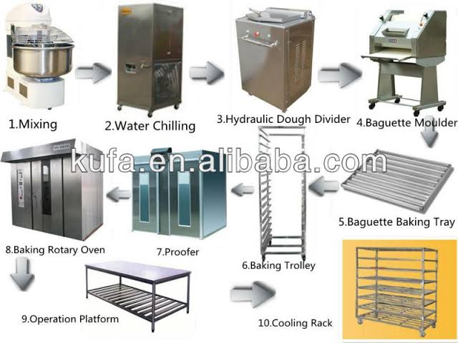
The dry heat of baking changes the form of starches in the food and causes its outer surfaces to brown, giving it an attractive appearance and taste. The browning is caused by caramelization of sugars and the Maillard reaction. Maillard browning occurs when "sugars break down in the presence of proteins. The moisture is never entirely "sealed in"; over time, an item being baked will become dry. This is often an advantage, especially in situations where drying is the desired outcome, like drying herbs or roasting certain types of vegetables. The baking process does not require any fat to be used to cook in an oven. When baking, consideration must be given to the amount of fat that is contained in the food item. Higher levels of fat such as margarine, butter, lard, or vegetable shortening will cause an item to spread out during the baking process. With the passage of time, breads harden and become stale. This is not primarily due to moisture being lost from the baked products, but more a reorganization of the way in which the water and starch are associated over time. This process is similar to recrystallization and is promoted by storage at cool temperatures, such as in a domestic refrigerator or freezer.
ADVANTAGES AND DISADVANTAGES OF BAKING FOOD
Baked food has several advantages. Due to the caramelizing process, baked dishes are more flavorful than boiled dishes. Baked recipes call for very little amount of fat as compared to other methods of cooking, such as frying and roasting. Also, baking food in an oven results in lesser emissions of toxic byproducts like smoke. The food gets cooked, reducing the chance of food poisoning and making the food tender. The food will warm you on a cold day.
There are also certain disadvantages of baking. Certain processed such as boiling and steaming require no use of fat, which is healthier as compared to baking, as it requires some amount of fat.
Also baking tends to be a slower process as compared to cooking methods such as frying and boiling.

FLAKING OF CEREALS
Cereal Flakes is a food product made of corn, wheat, rice, oats, and other cereal grains; it is prepared by removing the outer coating from the seed, processing the grain into grits, cooking the grits in a sugar and salt syrup, and rolling out the meal into thin flakes, which are then toasted in ovens. Flaked cereals are partially cooked and can be used as quick-cooking or ready to eat foods. The grains are softened by partially cooking in steam. They are then pressed or rolled into flakes which are dried.
APPLICATION AND PROCESSING
Flaking processing of cereals is used to make common breakfast cereal. Flaked breakfast cereals can be divided into two groups: flakes made from whole grains or parts of the whole grains, and flakes made from more finely ground materials that must be first extruded into pellets that can then be rolled into appropriate-size flakes. The whole grains (wheat and rice) or major components (such as grits from de-germed yellow maize or corn) are cooked with flavorings such as sugar, salt, and malt; they are then dried and tempered to a firm but slightly plastic state, flaked by passing between rolls, and toasted or dried to a final specified moisture content. Cooking of grits or whole grains for traditional flakes is usually done in batches. The moisture content of the cooked mass at the end of cooking is usually about 28%. The cooked material should not be mushy, soft, or sticky. After cooking, the mass of material is cooled, dried at about 120 °C, and tempered (held) for several hours at final equilibrated moisture content of 10–18%, depending upon the grains. The tempering process is important, not only to allow equilibration of moisture within the cooked grains or pellets, but also to allow sufficient starch recrystallization or retro gradation to provide a suitable texture for flaking. Flaked cereals can also be made from extruded pellets rather than cooked grits or whole grains. A variety of floury or finely ground grain products such as whole wheat or oat flour can be mixed with sugar, salt, and malt syrup or other flavoring and coloring ingredients to form a dough. This is then extruded to form pellets about the same size as cooked grits or whole grains, the cooking having taken place in the extruder. Pellet moisture is in the range of 18–24%. Conditioning or tempering prior to flaking may or may not be required. Whether consisting of cooked grits or whole grains or of extruded pellets, the tempered material is then flaked. Tremendous pressures are necessary to flatten the prepared material into thin flakes, which traditionally have been toasted by keeping them suspended in hot air between 270°C and 330 °C for about 90 seconds. Some properties of the finished flakes can be modified by a heating or steaming step immediately before flaking (e.g., infrared heating immediately before flaking will increase the tendency of flakes to crinkle rather than remain flat), while other properties, such as blistering, color, crispness, tenderness, and flavor of the final product, are influenced by toasting conditions. The moisture content of the finished product is about 1–3%.The thermo- flaking cereals process improves organoleptic, chemical and physical characteristics of cereals and legumes used in feed rations of all types of animals, making in such a way easier the digestibility and highly improving the productive performances of the rearing.

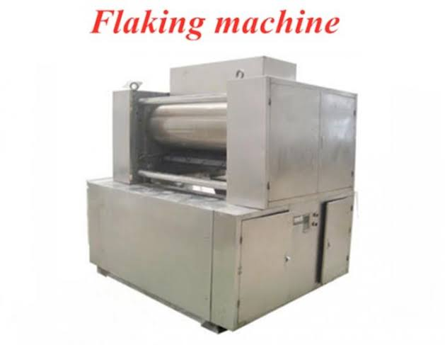
The transformation of cereal grains into flakes offers remarkable advantages, both nutritional and sanitary. Here are some of them;
- Outside modification of feed.
- Molecular modification of starch.
- Increase of feed digestibility.
- Sanitary qualification of feed.
- High increase in palatability.
- Improvement of satiety sensation.
- Elimination of anti-nourishing factors.
- Optimum utilization of feed of a low biological value.

